C

Men & Women

* Coats
* Sleeping Bags
* Blankets
* Hats & Gloves & Scarves
* Socks
* Boots
* Winter Items

**Monetary Donations if Preferred can be made at our Website**: [WWW.LOAVESNFISHESNV.ORG](http://WWW.LOAVESNFISHESNV.ORG)

Or PO Box 5445, Reno Nevada 89513

Questions Contact: Kristi Wilson @ (775) 954-8701 | Please See Website For Any Rain Dates

**Can You Help By Donating These Gently Used Items?**

Elementary Kids K-12

* Coats
* Hats & Gloves & Scarves
* Gently Used Clothing
* Gently Used Boots & Sneakers
* Children’s Blankets/Sleeping Bags

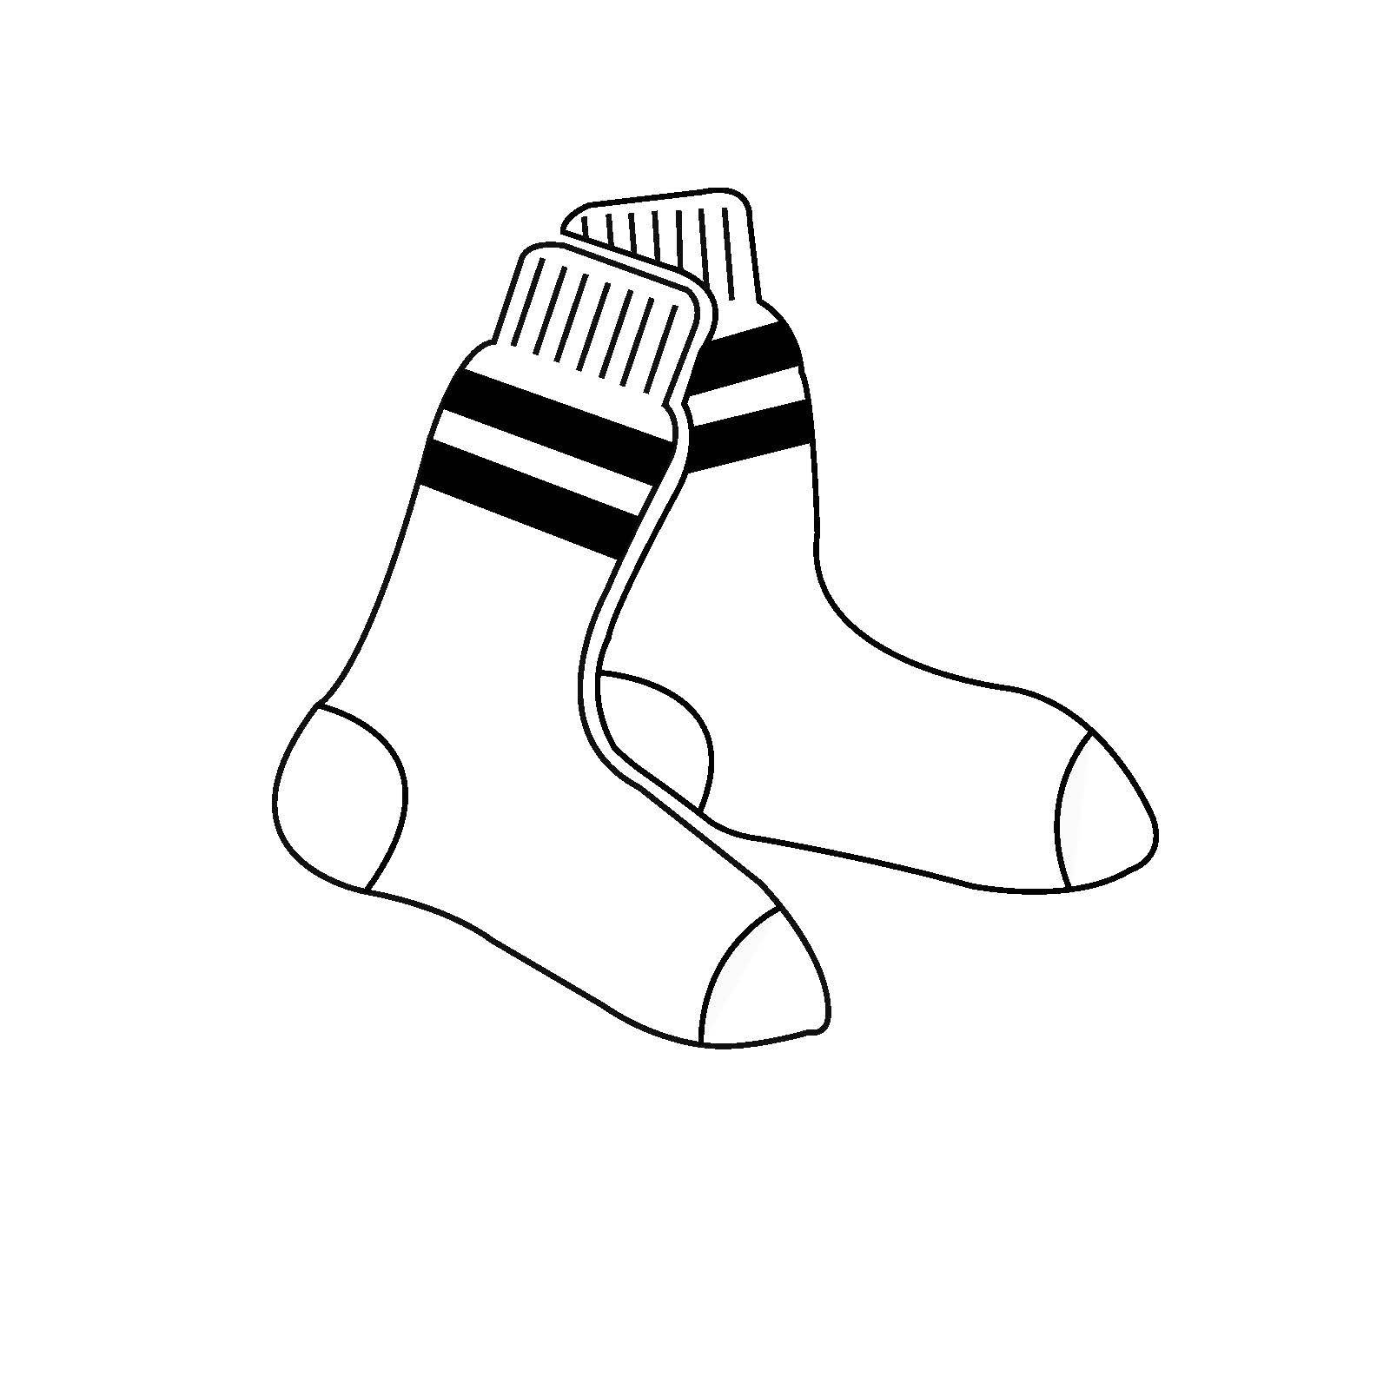

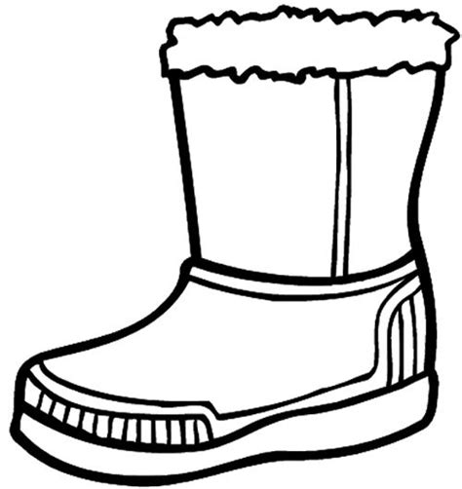



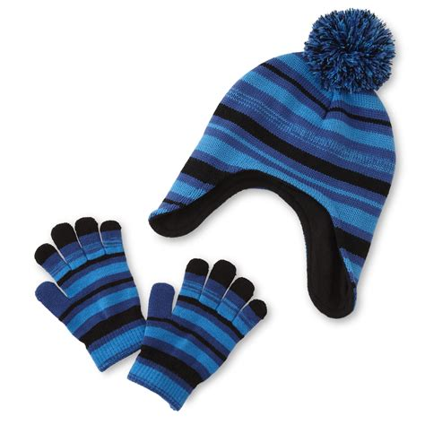

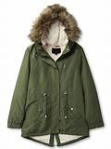

**2025 Loaves & Fishes**

**14th Annual Winter Weather Outreach**

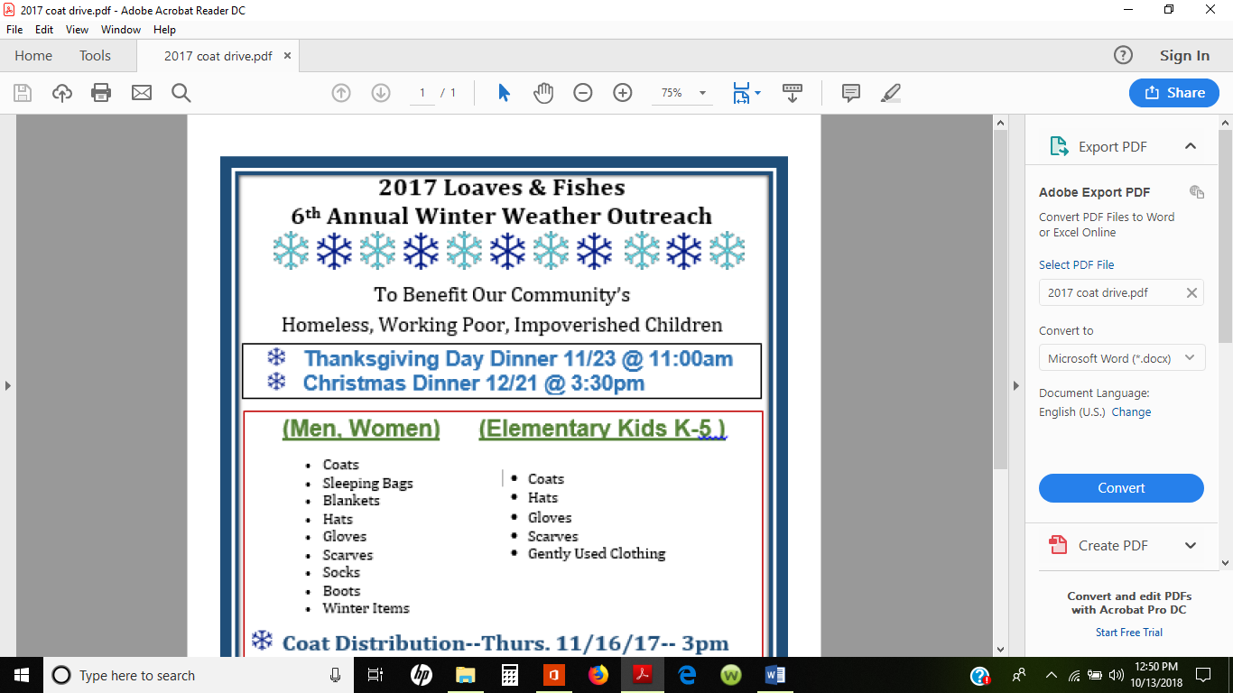

T*o Benefit Our Community’s*

*Homeless, Working Poor, Impoverished Children*

 **Coat Distribution Day**: Thursday November 6, 2025 at 1:00-3:00pm

 **Thanksgiving Dinner**: Thursday November 27, 2025 at 1:30pm

**Christmas Dinner:** Thursday December 18, 2025 at 3:30pm



 **New Year’s Dinner**: Thursday January 1, 2026 at 3:30pm

ALL EVENTS TO BE HELD AT: Barbara Bennett Park | 400 Island Ave, Reno, NV 89501

