C
Men & Women
- Coats
- Sleeping Bags
- Blankets
- Hats & Gloves & Scarves
- Socks
- Boots
- Winter Items

Monetary Donations if Preferred can be made at our Website: WWW.LOAVESNFISHESNV.ORG
Or by MAIL: PO Box 5445, Reno Nevada 89513
Questions Contact: Kristi Wilson @ (775) 954-8701 | Please See Website For Any Rain Dates
Can You Help By Donating These Gently Used Items?
Elementary Kids K-12
- New & Gently Used Coats
- Hats & Gloves & Scarves
- Gently Used Clothing
- Gently Used Boots & Sneakers
- Children’s Blankets/ Sleeping Bags
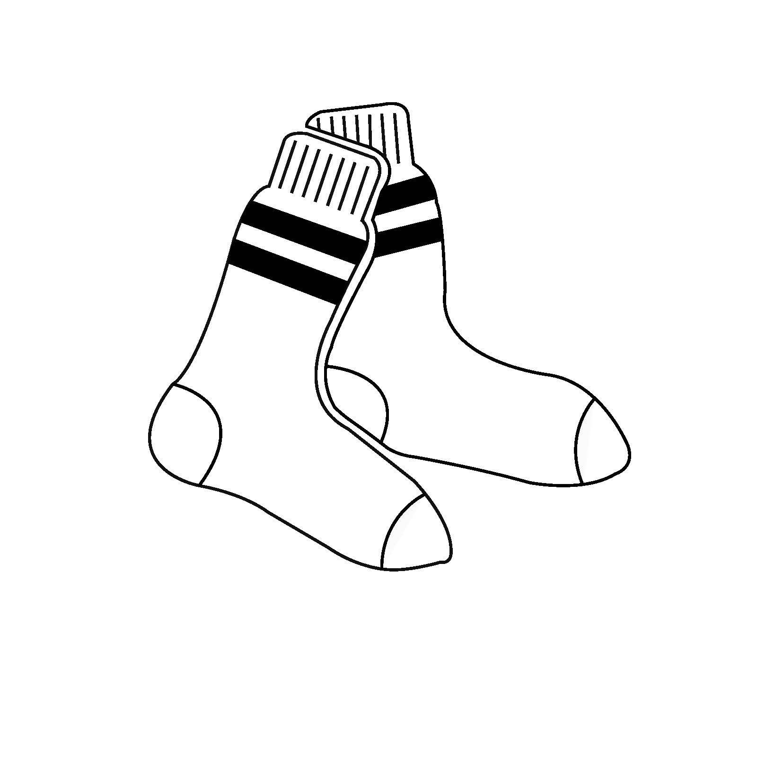
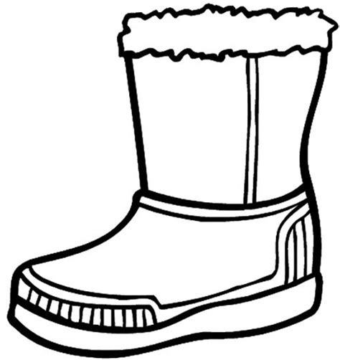

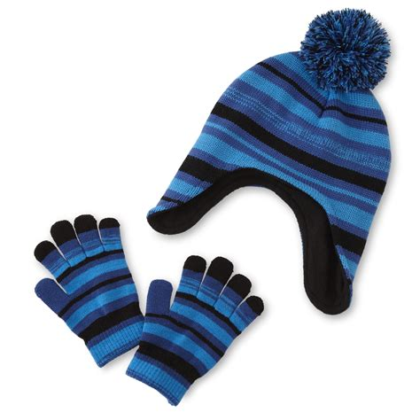
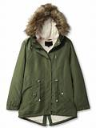
2026 Loaves & Fishes
15th Annual Winter Weather Outreach
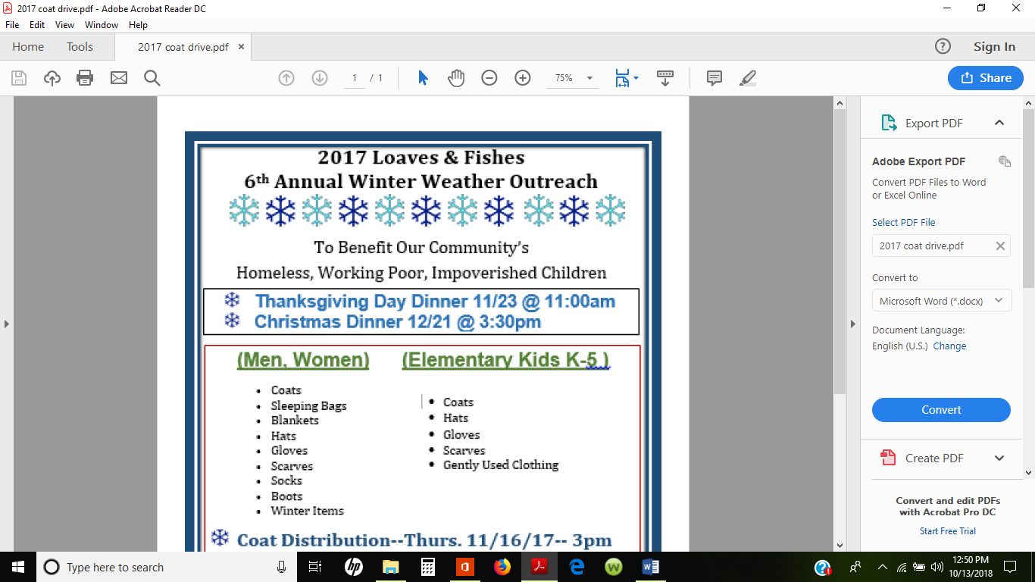
To Benefit Our Community’s
Homeless, Working Poor, Impoverished Children

Coat Distribution Day: Thursday November 5, 2026 at 1:00-3:00pm
 Thanksgiving Dinner: Thursday November 26, 2026 at 1:30pm
 Christmas Dinner: Thursday December 24, 2026 at 3:30pm
 New Year’s Dinner: Thursday January 7, 2027 at 3:30pm
ALL EVENTS TO BE HELD AT: Barbara Bennett Park | 400 Island Ave, Reno, NV 89501

